Clash of Clans Mobile App User Manual

Clicking on the application icon will take you to the “landing page” that looks like the following picture:

Landing Page
Landing Page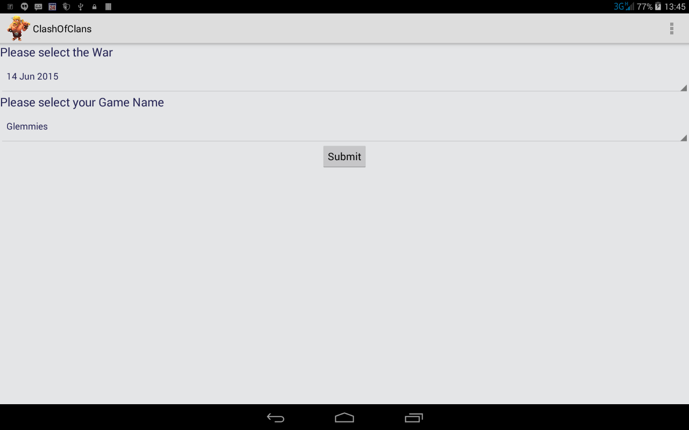
- Please Select the War.
  - This will normally only consist of one item and should not need to be selected.
- Please select your Game Name:
  - This is a “Dropdown” list of all the participants of the related war. Select your own “Game Name” to continue.
- Submit button:
  - Pressing this button will take you to the “Opponent Selection and Suggestion” page as shown later in this document.
At the top right of the “Landing page” is three dots below one another. This is a menu and when selected will bring up a menu that looks like the menu in the “Stats Menu” page that follows

Stats Menu
Stats Menu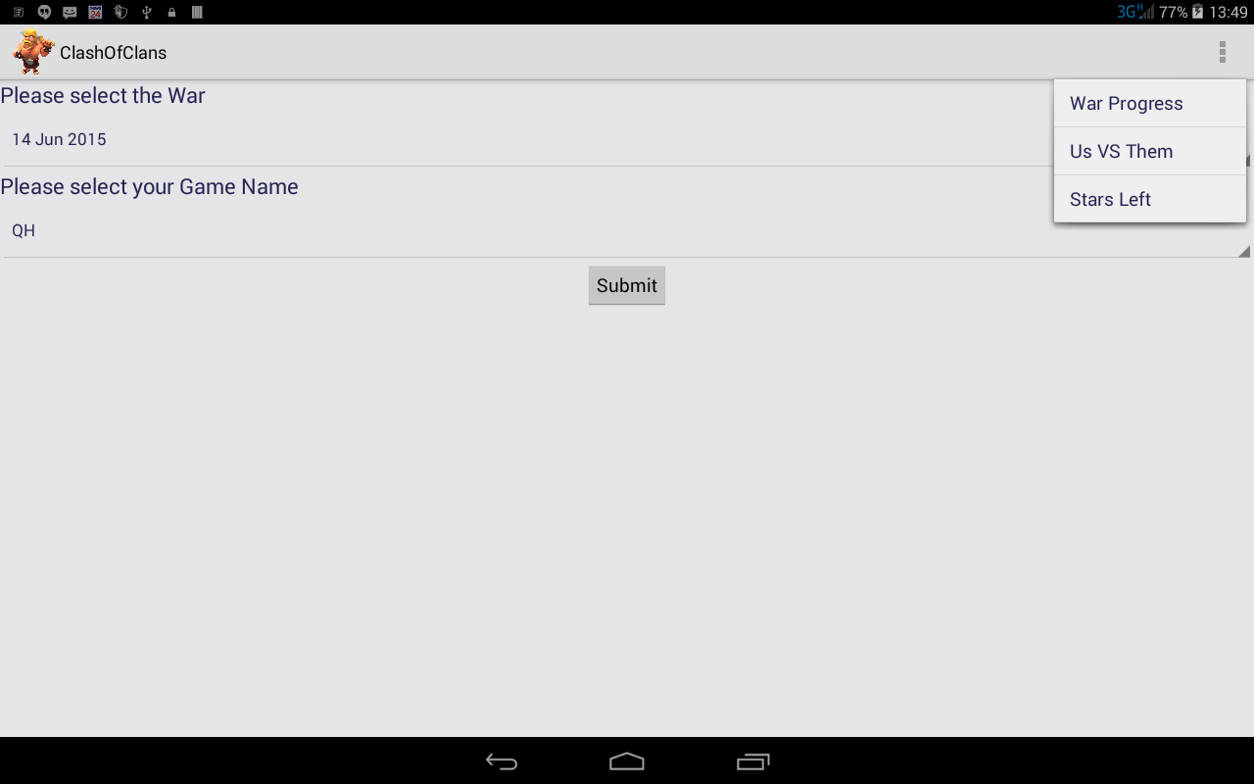
- War Progress
  - This menu will take you to the “War Progress” page that displays the current stars that has been taken by the different players for their first and second attacks. If no attack has been made yet “No Attack” will be displayed instead of the stars. The following page illustrates what the page may look like:
War Progress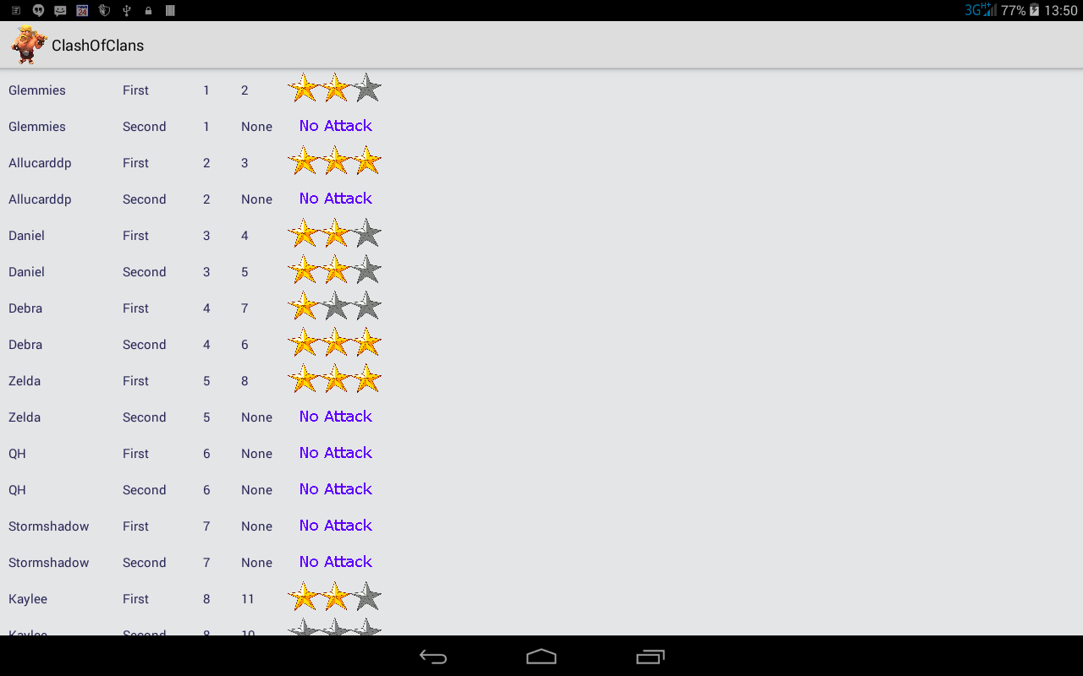
- Us Versus Them
  - This page gives general statistical information regarding the two clans involved by displaying the experience and Town hall level of each participant. An example of such page follows:
Us Versus Them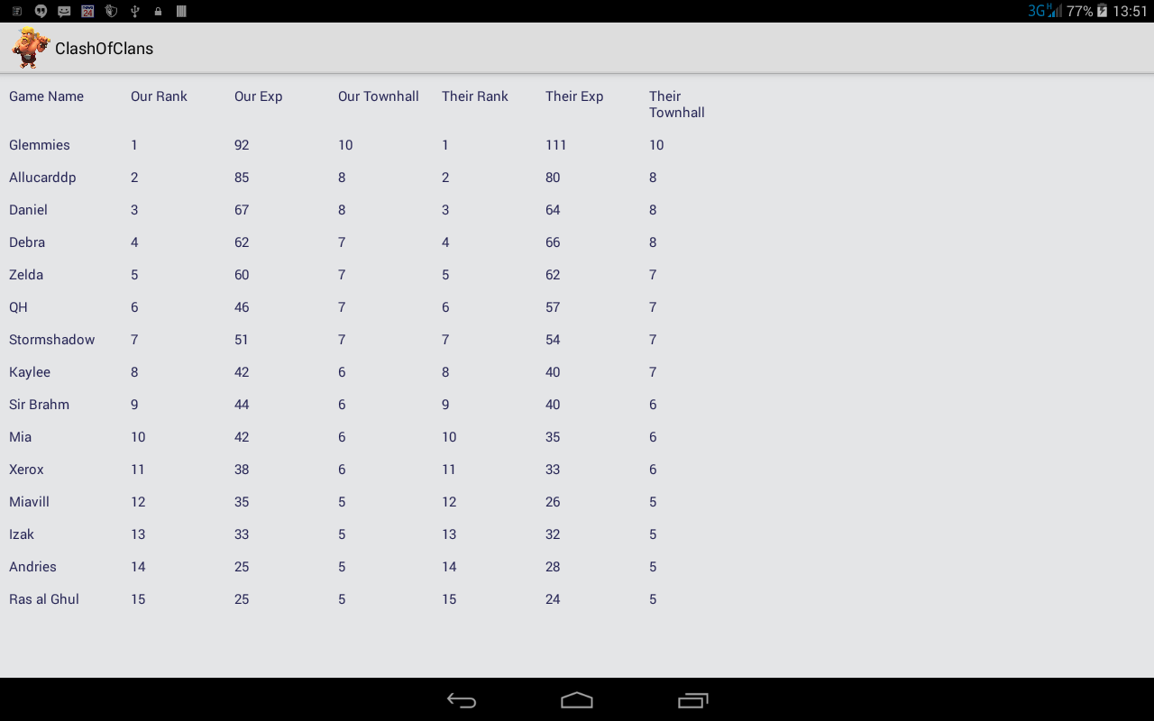
- Stars Left
  - This page displays the number of stars that is left to take. In the page that follows their number 2 rank player has one star left that can be taken, thus two stars have already been taken from him. In the case of the player with rank 7, there is still 2 stars left for the take, etc. The following picture illustrates this page:
Stars Left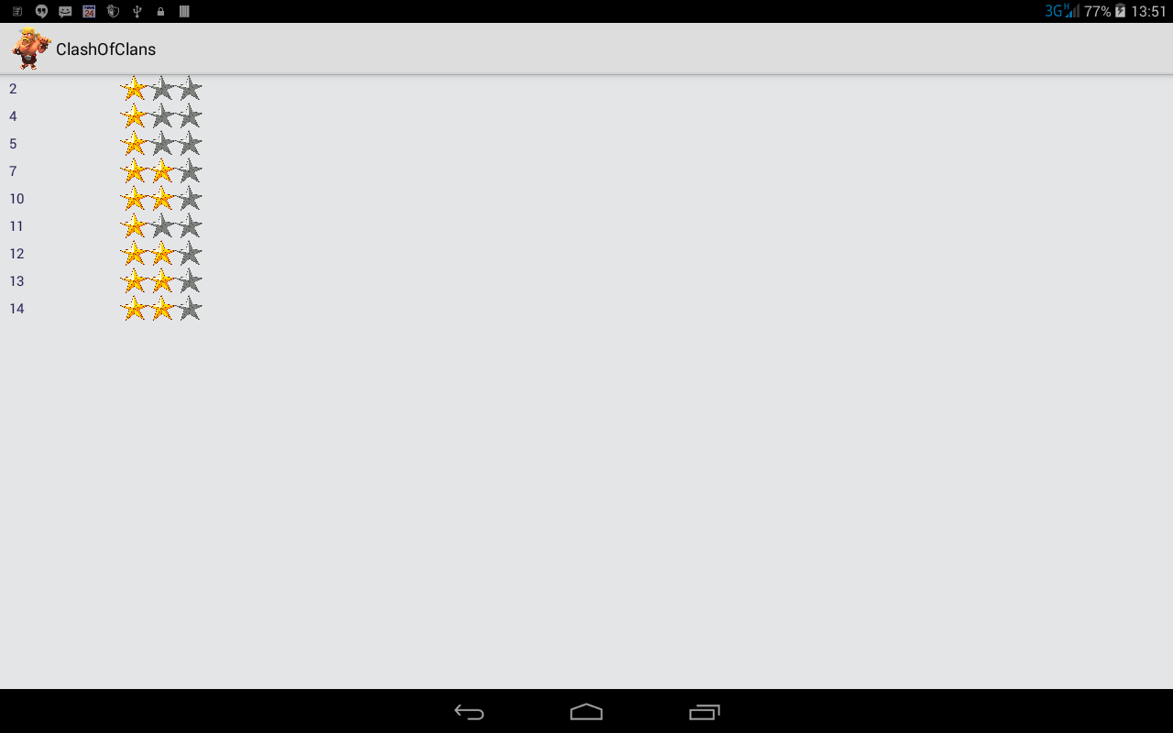

Opponent Selection and Suggestion
Opponent Selection and Suggestion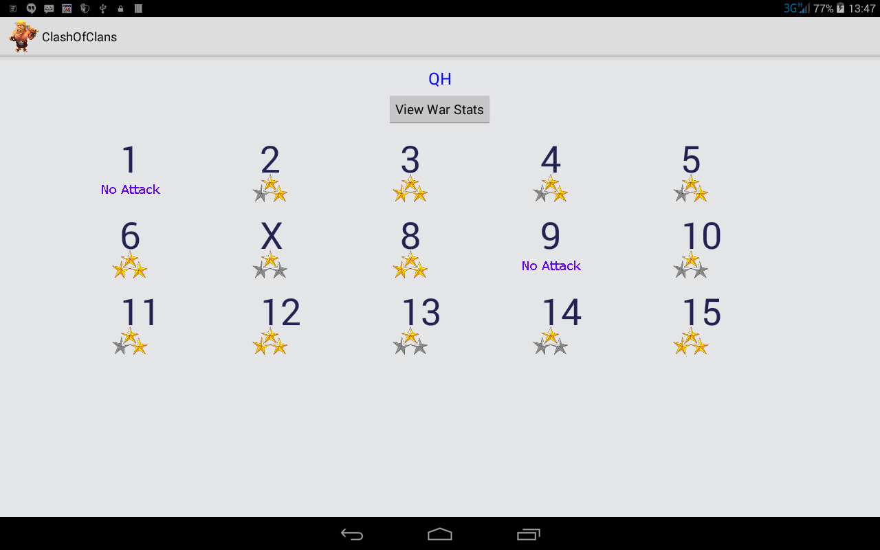
- This window displays the maximum stars that has already been taken from the various ranks of the opponents. “No Attack” obviously means that no attack has been made against a relevant opponent. “X” indicates the recommended target for the player that was selected in the previous window “Landing Page”. If there is no opponent marked with an “X” it probably means that the player has already made two attacks or that the program is unable to make a meaningful suggestion. If there is no action when you click on a number that will mean that you already made 2 attacks.
- The first thing that happens when you select an opponent is that the system will check if anybody else is currently busy with an attack. If that is the case the system will not allow you to continue until the other player finished his attack. This is of course to make sure that 2 or more players does not simultaneously attack the same opponent and to enable the system to make a more appropriate decision as to the next attack.
- Once the player click on a number and nobody else is busy with an attack the system will “lock” the system for the current player. The system will only release the “lock” after the player has entered his score.
- NB!!! Please only select an opponent if you are about to make an attack and you do not want to allow anybody else to make an attack in the meantime.

Stars won Selection
Stars Won Selection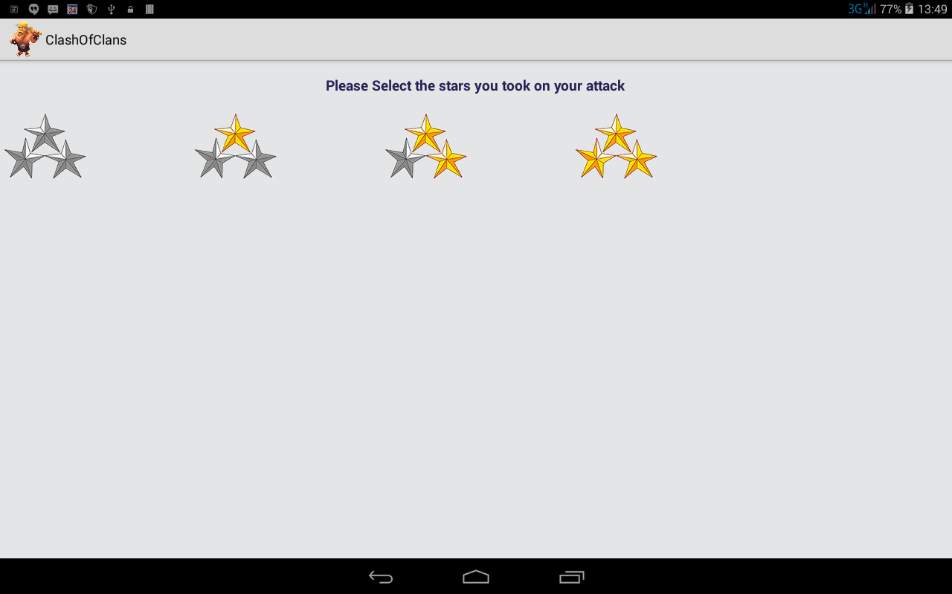
- In this window you select the number of stars that you took from your opponent. A confirmation will be asked after selection and then the “Lock” will be released so that other players can continue with their attacks. Clicking on the “Back” button (the farthest left button at the bottom of the screen) will also release the “lock” but without capturing a score.

